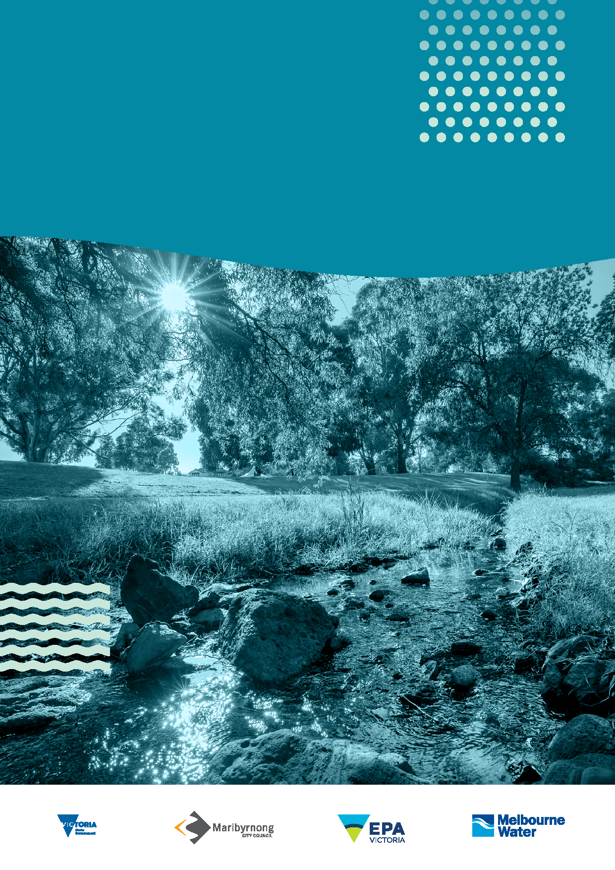
Stony Creek Rehabilitation Plan Annual report card
2022-2023
Victoria State Government, Maribyrnong City Council, Environment Protection Authority Victoria, Melbourne Water

Contents
Overview 3
Highlights 6
Water quality sensors provide real-time insights 7
Report card 10

Acknowledgement of Country
Melbourne Water respectfully acknowledges the Bunurong, Gunaikurnai, Taungurung, Wadawurrung and Wurundjeri Woi-Wurrung peoples as the Traditional Owners and Custodians of the land and water on which we rely and operate. We pay our deepest respects to their Elders past, present and emerging.
We recognise Bunurong as the Traditional Owners and Custodians of the country through which lower Stony Creek winds and joins Port Phillip Bay and the Wurundjeri Woi-Wurrung as the Traditional Owners and custodians of the country through which upper Stony Creek meanders. We recognise and respect the continued cultural and spiritual connections that Aboriginal and Torres Strait Islander peoples have with land and water they have cared for and protected for thousands of generations.
We demonstrate our ongoing commitment to reconciliation through our partnerships with Traditional Owners and the broader Aboriginal and Torres Strait Islander communities, as we work together to manage land and water now and into the future, while maintaining and respecting cultural and spiritual connections.

Overview
Melbourne Water, Maribyrnong City Council, Environment Protection Authority Victoria (EPA Victoria), research partners and the local community are working together in a sustained effort to deliver improvements in how we rehabilitate and protect Stony Creek following the August 2018 Tottenham warehouse fire.
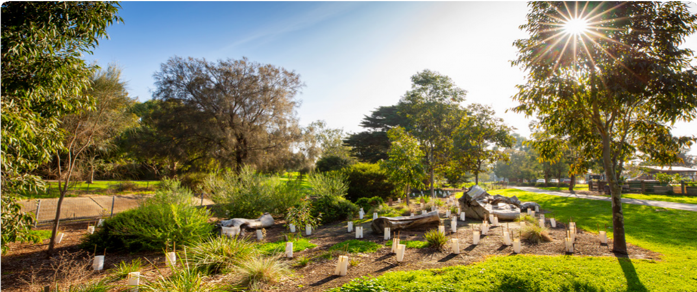
Planting in Cruickshank Park, Yarraville
The Stony Creek Rehabilitation Plan (2019–2029) (the Plan) was developed in response to a warehouse fire that burned for two weeks in August 2018. The runoff from the fire washed into Stony Creek devastating a five kilometre stretch of the creek. Project partners including Melbourne Water, Environment Protection Authority Victoria, Maribyrnong City Council and the local community worked together to develop the Plan to rehabilitate and protect the creek. We developed a vision to bring the community together to connect with nature and transform Stony Creek.
This is the Plan’s fourth annual report card and provides an update on the status and progress of actions from September 2022 to August 2023.
This report card includes 16 actions that were in progress this year. The initiatives that have progressed include water quality monitoring and research, pollution prevention action and community education. We took time to celebrate what we have worked together to achieve.
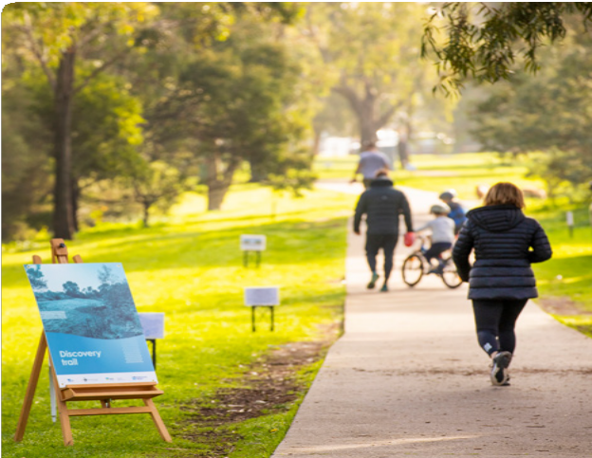
Friends of Cruickshank Park created a discovery trail along Stony Creek
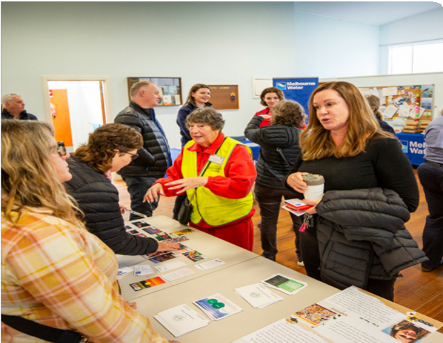
The report card launch provided an opportunity to showcase activities that help protect Stony Creek
In 2022, our research partners at RMIT University released the Stony Creek litter investigation.
When the report was finalised, Melbourne Water, Maribyrnong City Council and Environment Protection Authority Victoria worked together to consider its recommendations. By prioritising pollution management actions we can optimise the impact they have.
Friends of Stony Creek and Friends of Cruickshank Park hosted a wide variety of community events throughout the year. It was an active period for Friends of Stony Creek whose members were busy speaking to interested locals, welcoming new members and fundraising through book and plant sales. Activities included four clean up days, regular WaterWatch monitoring and four weeding and planting days supported by Melbourne Water, Maribyrnong City Council and Brimbank Council.
For Friends of Cruickshank Park 2023 was particularly significant, the year marking 50 years since the group was established. Efforts over this time have transformed the former quarry site from an area covered with weeds and rocks to the leafy park that now supports a thriving ecosystem for the local community to enjoy. The Friends of Cruickshank Park hosted a 50th birthday party where hundreds of people celebrated this remarkable achievement.
In June 2023 Melbourne Water, Environment Protection Authority Victoria and Maribyrnong City Council came together with the local community and research partners to launch the previous annual report card. See the highlights sections below to learn more about the progress and knowledge shared as part of this event.
Community groups noted more local residents attending events than previous years and greater participation in activities that help protect and improve Stony Creek. The work included planting and weed removal to help establish a continuous corridor of habitat for frogs and birds along Stony Creek. Among the achievements are actions that fall under five key themes:
- Waterway health
- Water quality
- Education and participation
- Amenity
- Access

Highlights
Celebrating the launch of the Stony Creek Report Card in 2023.
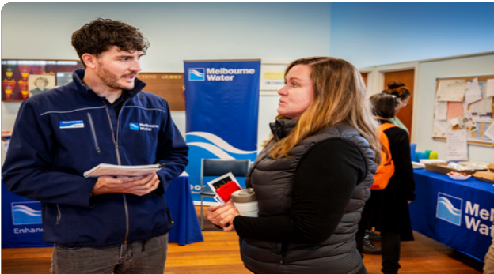
The event included time to talk and discuss our progress with researchers, Environment Protection Authority, Maribyrnong City Council and Melbourne Water
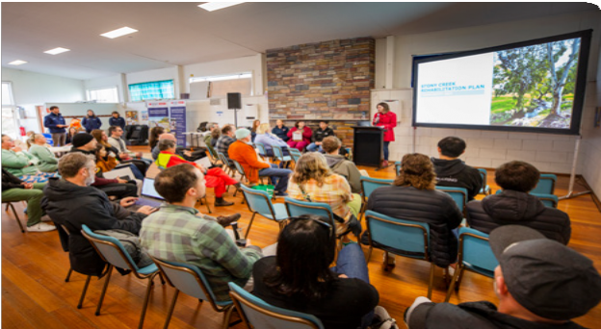
The panel presentation included researchers from Aquatic Pollution Prevention Partnership (A3P), RMIT University and Monash University and was introduced by Katie Hall MP
Melbourne Water, Environment Protection Authority Victoria, Maribyrnong City Council, Friends of Stony Creek, Friends of Cruickshank Park and the community have established and sustained a collaborative effort to protect and improve Stony Creek. This year we celebrated the progress we have made by hosting a Report Card Launch at Cruickshank Park, Yarraville. This community event provided a chance to hear directly from researchers and agency partners, share the highlights from the report card and get involved in caring for our local waterway.
The launch was the first opportunity since COVID lockdowns, for all agencies, partners and community delivering the Stony Creek Rehabilitation Plan, to get together in-person. The event featured research presentations, expert panel discussion and an agency report card update. After the networking lunch, the community were invited to participate in outdoor activities along Stony Creek in Cruickshank Park. These activities included a walk and talk discovery trail that visited the frog pond, shared how raingardens work and participation in a WaterWatch water quality testing activity. The day concluded with a community planting hosted by Maribyrnong City Council that was well attended and attracted the interest of people visiting the park. Over 60 local residents participated and many took the opportunity to speak directly with staff from Melbourne Water, Environment Protection Authority Victoria and Maribyrnong City Council to discuss our shared purpose, to protect Stony Creek.
Environment Protection Authority Victoria, commented:
“Attendance was terrific; considering how long that this has been active the number of community members who attended were terrific. Not only that, they were an engaged group as well.”
Friends of Stony Creek, commented:
“It was great to hear the work being done on water quality research and real-time pollution monitoring and response.”

Water quality sensors provide real-time insights
Stony Creek Sub-Catchment Monitoring Data
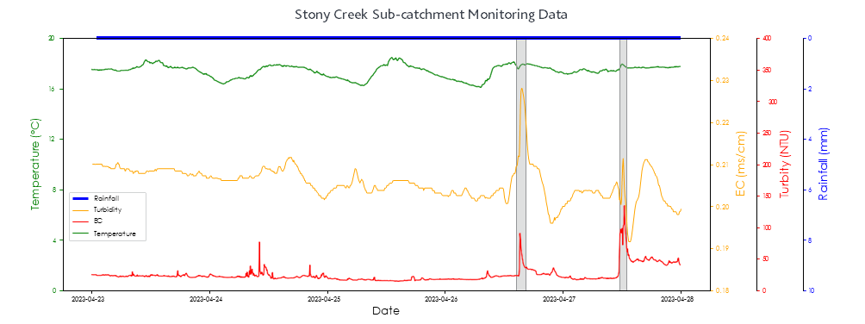
Figure 1. An example of detection at a Stony Creek Sub-catchment, the shaded areas in grey show obvious changes of electrical conductivity, temperature and turbidity during dry weather period indicating pollution in the creek.
This year Melbourne Water, Maribyrnong City Council and Environment Protection Authority Victoria continued working together with Monash University on the delivery of a water quality sensor trial. The Real-time sensing framework for pollution detection and response in the Stony Creek catchment involves using low-cost sensors within the Stony Creek Catchment to gather data on stormwater quality. The study tests a network of sensors that were installed throughout the Stony Creek catchment to capture information about the water that drains into Stony Creek from different areas. The research group monitored water quality for a 6-month period and shared their progress with Melbourne Water and Environment Protection Authority Victoria.
By analysing the water quality data during dry weather days and monitoring for spikes or unusual patterns, we can gain valuable insights into unusual discharges within the catchment. Researchers found that changes in data can indicate pollution events. This information allows for targeted actions to be taken, where and when pollution events occur.
On February 10, 2023, an incident involving the release of dye occurred, making the water in Stony Creek pink. Remarkably, this event aligns with a visible change in the monitoring data, shown in Figure 1 as spikes in temperature, electrical conductivity (EC), and turbidity.
In response Melbourne Water and Environment Protection Authority Victoria worked together to contain the spill and reduce the impact on the creek.
Environment Protection Authority Victoria identified the substance and were able to track the pollution to its source. The polluter was issued a clean out order.
By analysing the data, researchers can identify where there are frequent abnormal changes that indicate pollution hotspots. We can monitor hotspot areas more closely and concentrate our efforts to accurately detect pollution and find its source.
The next phase of the trial involves detailed monitoring of a smaller part of the Stony Creek catchment that was identified as a pollution hotspot. The trial will help improve water quality management by identifying the type of pollution, when and where it occurs.
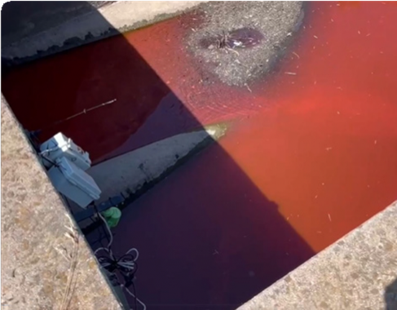
This dye discharge event was detected by the data and discoloured the water that flows into the creek.
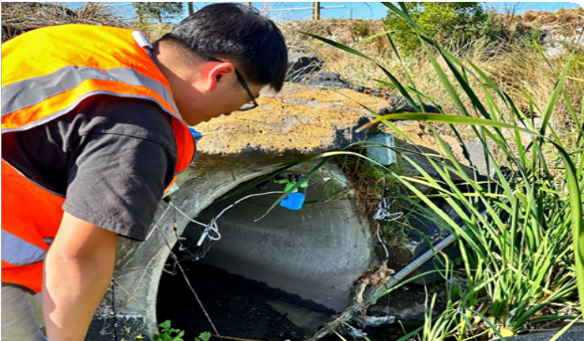
Water quality sensor site visit
Did you know?
Electrical conductivity (EC) can tell us a lot about water quality. Changes in electrical conductivity can be used an indicator of poor water quality from runoff or pollution.
Turbidity is a measure of how clear or cloudy the water is.

Report card
The report card includes status updates on 16 actions. Actions due in various years from 2019 to 2029 are in the report card, including actions to be reported on annually and actions that are in progress. For a full list of actions for the 10-year program, please see the Stony Creek Rehabilitation Plan (2019–2029).
As outlined in the Plan, each action has a code (for example WH 1, WH 2 etc) which indicates its priority (1 being highest priority; 10 being lower priority). These were ranked in priority order according to the community. Completed actions from previous year’s Report Card are not in this table.

Key theme | Code | Action | Lead | Support | Timeframe | Status information as at August 2021 | Status
Waterway Health | WH 7 | Plant native vegetation to establish a continuous corridor along Stony Creek. Design revegetation to retain important sightlines in public areas | Melbourne Water | Maribyrnong City Council  Community groups (for example Friends groups)  West Gate Tunnel Project  Traditional Owner groups | 2022 | Friends of Stony Creek were successful in obtaining a Liveable Waterways Liveable Community Incentive for pest control and revegetation.  Friends of Stony Creek held four planting days at Hyde Street Reserve planting, weeding and mulching activities were conducted to extend and infill the existing plantings at the eastern end of the reserve and to control invasive weeds particularly in the grassland area.  A community planting, led by Maribyrnong City Council with assistance from Friends of Stony Creek, Friends of Cruikshank Park and local volunteers, was held at the Stony Creek Rehabilitation Plan - Report Card Launch at Cruickshank Park.  Plantings provide habitat for local fauna such as skinks and owls. | In Progress
Water Quality | WQ 2 | Install water quality sensors throughout the catchment to investigate sources of pollution and litter, and enable a targeted response | Melbourne Water  Environment Protection Authority Victoria | Maribyrnong City Council | 2019 | Melbourne Water continues to work with Environment Protection Authority Victoria and Monash University on the water quality sensor project; a partnership that was initiated in 2022 in the Stony Creek catchment.  The first phase of the project trial involved deploying and monitoring water quality sensors in the Stony Creek stormwater network and concluded in June 2023.  A second phase involves detailed monitoring and investigation of a smaller part of the catchment.  Environment Protection Authority Victoria has provided technical, scientific and operational advice and expertise to the project to ensure the outcomes will help agencies better understand, investigate and prevent sources of pollution and litter.  Trials have been undertaken and initial processes developed to help stakeholders target their response and use information in operational decisions.  See highlights for further information. | In Progress
Water Quality | WQ 3 | Work with industry to ensure compliance regarding stormwater management and pollution prevention | Environment Protection Authority Victoria | Melbourne Water  Maribyrnong City Council | 2029 (Annual) | Environment Protection Authority Victoria officers have continued to inspect and work with businesses in the Stony Creek catchment to prevent and manage stormwater pollution. Environment Protection Officers (EPO’s) and Officers for the Protection of the Local Environment (OPLE’s) have provided a range of compliance advice, guidance material and taken regulatory actions to ensure businesses improve knowledge, understanding and compliance with the prevention-based Environment Protection Act 2017. Environment Protection Authority Victoria’s Western Metropolitan Region, Industry Guidance Unit (IGU), Public Affairs Branch (PAB), and other working groups, have been actively engaging with a wide range of industry groups, and individual business owners across Victoria.  In 2022-23 Environment Protection Authority Victoria ran proactive operations to reduce harm to waterways in Melbourne’s west and used social media, localised media and newsletters to reach thousands of businesses and stakeholders with simple information and guidance on preventing chemical spills, stormwater and waterway pollution. | In Progress
Water Quality | WQ 5 | Provide incentives for private and public landholders to implement stormwater quality improvement measures on their land | Melbourne Water  Environment Protection Authority Victoria | Maribyrnong City Council  Private landowners  Public land managers | 2029 (Annual) | In addition to Environment Protection Authority Victoria’s key 2022/23 programs and their ongoing outcomes, the Environment Protection Authority Victoria Industry Guidance Unit (IGU) released the following guidance material to improve business operations and waterway health:  Guidance for risk assessment of wastewater discharges to surface waters, EPA Victoria Publication 1287  Hydrogeological assessment guidelines for groundwater quality EPA Victoria Publication 668.1 | In Progress
Water Quality | WQ 9 | Place litter traps in appropriate places throughout the Stony Creek catchment | Melbourne Water | Maribyrnong City Council  Environment Protection Authority Victoria | 2021 | RMIT and the Aquatic Pollution Prevention Partnership (A3P), presented the research What’s in our water? An investigation of water quality in Stony Creek at the Stony Creek Rehabilitation Plan –report card launch.  There was strong community interest in the outcomes of this research.  Melbourne Water and Maribyrnong City Council have discussed methods to prioritise recommended actions from Stony Creek litter investigation report (1.3 MB). | In Progress
Water Quality | WQ 10 | Regular reporting by Council and Environment Protection Authority on compliance with stormwater management regulations across the catchment | Maribyrnong City Council  Environment Protection Authority Victoria | N/A | 2029 (Annual) | Environment Protection Authority Victoria received approximately 50 pollution reports in and around Stony Creek catchment for the financial year 2022-23, which included 32 follow up inspections, 10 remedial notices and two sanctions.  Environment Protection Authority Victoria publishes annual statistics on inspections and pollution reports on an ongoing basis. | In Progress
Education & Participation | E1 | Engage and educate industry about better practices | Environment Protection Authority Victoria | Maribyrnong City Council | 2029 (annual) | Environment Protection Authority Victoria developed and delivered a plan for proactive engagement of priority stakeholders to monitor and manage waterway health. Environment Protection Authority Victoria’s Environment Protection Officers (EPO’s), Officers for the Protection of the Local Environment (OPLE), and Senior Engagement Leads (SEL) engaged with businesses to ensure that General Environmental Duty (GED) principles were embedded in all strategic and operational work. Environment Protection Authority Victoria, MW, Council and Traditional Owners continued to work together in both a strategic proactive and responsive capacity, to prevent harm from pollution and waste.  Environment Protection Authority Victoria continued to focus on illegal waste stockpiling, inappropriate storage of materials and wastes, and management of wastes, including the choice of transporter of wastes, and the receiver of wastes. As also mentioned above, in 2022-23 Environment Protection Authority Victoria ran proactive operations to reduce harm to waterways in Melbourne’s west and used social media, localised media and newsletters to reach thousands of businesses and stakeholders with simple information and guidance on preventing chemical spills, stormwater and waterway pollution. | In progress
Education & Participation | E2 | Play-based learning and participatory community assets | Maribyrnong City Council  Education providers | Community groups | n/a | Maribyrnong City Council delivered a workshop with Kingsville Primary to learn about habitat and wildlife by;  - checking nesting boxes,  - caring for new plants  - walk and talk to visit both the rain garden and frog pond to learn about pollution and its impact on the creek and how all play a part in protecting the waterways. | In progress
Education & Participation | E8 | Routine publishing of test results on publicly available websites | Environment Protection Authority Victoria  Melbourne Water  Maribyrnong City Council | Community groups (for example Friends groups) | 2029 (Annual) | EPA Victoria publication 1872 provides Stony Creek water quality monitoring results downstream of the 2018 Tottenham chemical storage factory fire.  Environment Protection Authority Victoria forecasts summer water quality for 36 beaches in Port Phillip Bay  Environment Protection Authority Victoria also issues water quality alerts when there is an issue affecting a water body in Victoria.  Friends of Stony Creek have been actively monitoring a Stony Creek site downstream of Somerville Road, Yarraville and submitting their results to Waterwatch. This data and information on community water monitoring is available at: Water Watch Victoria website | In progress
Education & Participation | E9 | Education pieces along the trail linking to the Maribyrnong River to create a unifying element | Maribyrnong City Council | Melbourne Water  Traditional Owner groups  Community groups | 2021 | With support from the West Gate Tunnel Project’s, West Gate Neighbourhood Fund, Friends of Stony Creek worked with Maribyrnong City Council, designers and fabricators to install four new signs for a history trail from Cruikshank Park to Hyde Street Reserve. | In Progress
Education & Participation | E10 | Have more frequent community ‘pop up’ information events in Cruickshank Park for residents to find out about the creek | Maribyrnong City Council  Melbourne Water  Community groups (e.g. Friends groups) | Environment Protection Authority Victoria  Community groups  Interested community members | 2029 (annual) | Friends of Cruickshank Park celebrated 50 years since a community group was established. Hundreds of local residents and visitors attended the celebration including representatives for Maribyrnong City Council, Environment Protection Authority Victoria and Melbourne Water.  Events hosted by Melbourne Water this year included Bugs and Birds in Cruickshank Park with Waterwatch and the launch of the Stony Creek Rehabilitation Plan - 2021-22 Annual Report Card with Environment Protection Authority Victoria, Maribyrnong City Council, local friend’s groups and research partners  Friends of Stony Creek experienced a steady increase in the number of people attending events including planting, clean up days and attending Yarraville Festival Melbourne Water, Maribyrnong City Council and Brimbank Council have supported the events throughout the year. | In Progress
Amenity | AM1 | Add more plantings throughout the Stony Creek corridor | Maribyrnong City Council  Melbourne Water | Community groups (for example Friends groups)  Public land managers  Private land owners  West Gate Tunnel Project | 2022 | 7500 new plants have been installed along Stony Creek to help with erosion control, more habitat for wildlife, more nature for community to enjoy.  Increase wildlife corridor from to Duke St, Braybrook to Lower Stony Creek, Yarraville  - 4000 plants at Duke St  - 1000 plants at Sara Grove  - 2000 plants at Cruickshank Park, and  - 500 at Lower Stony Creek Reserve | In Progress
Amenity | AM 4 | More nature- based play to engage kids with their local flora and fauna | Maribyrnong City Council | Community  Education providers | 2025 | A series of large logs have been installed throughout Cruickshank Park to encourage children to engage in nature play by climbing and exploring. | In Progress
Amenity | AM 6 | Better use of open space | Maribyrnong City Council | n/a | 2029 | A concept plan for Lae St Nursery site was developed in consultation with the Community Advisory Group. | In Progress
Amenity | AM 8 | Rainwater storage for irrigation in Cruickshank Park to provide green spaces even over summer, and prevent barren sections during dry periods | Maribyrnong City Council | Melbourne Water | 2025 | Maribyrnong City Council’s Integrated Water Management Plan is in development and will consider water initiatives across Maribyrnong. This project is due for completion by 30 June 2024. | In progress
Access | AC 5 | Construct a shared path from Paramount Road to Cruickshank Park | Maribyrnong City Council | n/a | 2025 | Options for access to land to complete the missing link between Waratah and Roberts St, West Footscray are being considered. | In Progress

Melbourne Water
990 La Trobe Street, Docklands, Vic 3008
PO Box 4342 Melbourne Victoria 3001
Telephone 131 722 Facsimile 03 9679 7099
Melbourne Water Website
© Copyright March 2024 Melbourne Water Corporation. All rights reserved.
No part of the document may be reproduced, stored in a retrieval system, photocopied or otherwise dealt with without prior written permission of Melbourne Water Corporation.
Disclaimer: This publication may be of assistance to you but Melbourne Water and its employees do not guarantee that the publication is without flaw of any kind or is wholly appropriate for your particular purposes and therefore disclaims all liability for any error, loss or other consequence which may arise from you relying on any information in this publication.

https://www.rmit.edu.au/about/schools-colleges/science/research/research-centres-groups/aquatic-environmental-stress/projects/stony-creek-litter-project
https://www.melbournewater.com.au/about/what-we-do/publications/stony-creek-rehabilitation-plan
https://www.epa.vic.gov.au/about-epa/publications/1287-guidance-for-risk-assessment-of-wastewater-discharges-to-surface-waters
https://www.epa.vic.gov.au/about-epa/publications/668
https://www.rmit.edu.au/content/dam/rmit/au/en/research/networks-centres-groups/aquest/56-stony-creek-litter-investigation-management-prioritisation.pdf
https://www.epa.vic.gov.au/about-epa/publications/1872
https://www.epa.vic.gov.au/for-community/summer-water-quality/beach-report
https://www.epa.vic.gov.au/for-community/current-projects-issues/water-quality-alerts
http://www.vic.waterwatch.org.au/
https://www.yourcityyourvoice.com.au/laestreet
http://melbournewater.com.au/

